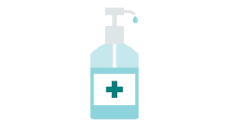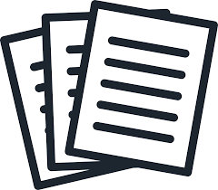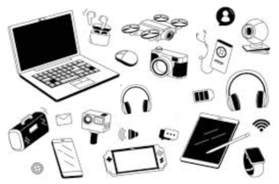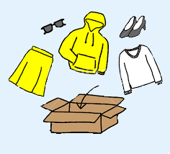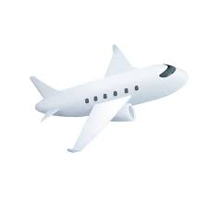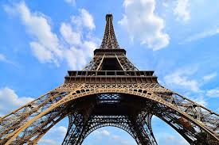

**Reflections**

* **What was interesting?:**
  + The panoramic view of Paris from the top of the Eiffel Tower was breathtaking. I was particularly fascinated by how the city’s layout and landmarks looked from above.
* **How was this ‘Reflective Travel Journal’ different?:**
  + This journal encouraged me to think more deeply about my experiences and the significance of what I saw. It made me more mindful of the little details and helped me appreciate the journey in a more meaningful way.
* **What did I learn?:**
  + I learned that Paris is even more beautiful and vibrant in person than in photos. I also realized the importance of planning ahead for major tourist attractions to avoid long wait times and make the most of the visit.

**Packing List**

* **Clothing:**
  + Comfortable walking shoes
  + Casual outfit
  + Light jacket
* **Hygiene products:**
  + Hand sanitizer
  + Tissues
* **Electronics:**
  + Smartphone and charger
  + Power bank
* **Travel Documents:**
  + Passport
  + Travel insurance
  + Metro ticket
* **Miscellaneous:**
  + Travel guidebook
  + Journal and pen
  + Snacks
  + Reusable water bottle

**Activities I did** (I’m now tired) -

* Arrived in Paris via train
* Visited the Eiffel Tower
* Lunch at a café in Montmartre
* Explored the Sacré-Cœur Basilica
* Strolled through the Latin Quarter
* Evening Seine River cruise

**Meals I had (That wasn’t cheap ) -**

* Breakfast: Croissant and coffee on the train
* Lunch: Quiche Lorraine and salad at a café in Montmartre
* Dinner: Crepes from a street vendor near the Seine

**Highlights I’d like to share (:**

* Viewing Paris from the top of the Eiffel Tower
* The charming streets of Montmartre
* The stunning architecture of the Sacré-Cœur Basilica
* The relaxing and scenic Seine River cruise

• **Challenges I faced ;)**

* Navigating through the crowds at the Eiffel Tower
* Finding a good spot to view the sunset over the Seine

• **Expenses (Basically A lot ;)**

* Breakfast: €5
* Lunch: €20
* Dinner: €10
* Eiffel Tower ticket: €25
* Seine River cruise: €15

**Destination:** Paris, France

**Dates of Travel:** June 1, 2024

**Purpose of Travel:** Exploration

**Weather:** 24°C

**Accommodation Details:** Hôtel Le Bristol Paris, 112 Rue du Faubourg Saint-Honoré, 75008 Paris, France

**Name**: Prince **Email**: IndividualCoder@gmail.com **Number**: 7290881294